 | Course Name: Advanced Web Technology | EXPERIMENT NO. 7
 | Course Code: 20CP314P  Faculty: Komal Singh | Branch: CSE
 | Course Code: 20CP314P  Faculty: Komal Singh | Semester: VI
Submitted by: Harsh Shah
Roll no: 21BCP359

Objective: Working with states in React
- Create a counter based on react states using both the approaches class component as well as functional component.
Approach 1: Class Component
import React from "react";
class App extends React.Component {
constructor(counter) {
super(counter);
this.state = {
counter: 0,
};
}
increment = () => {
this.setState((prevState) => ({
counter: prevState.counter + 1
}));
}
decrement = () => {
this.setState((prevState) => ({
counter: prevState.counter - 1
}));
}
render() {
return (
<div>
<h1>{this.state.counter}</h1>
<button onClick={this.increment}>Increment</button>
<button onClick={this.decrement}>Decrement</button>
</div>
);
}
}
export default App;

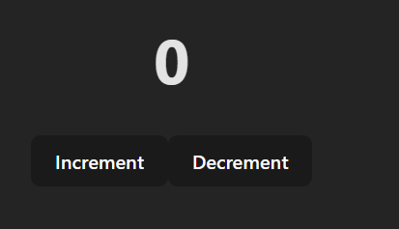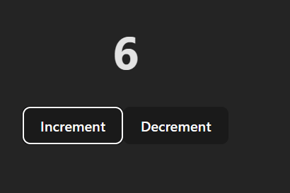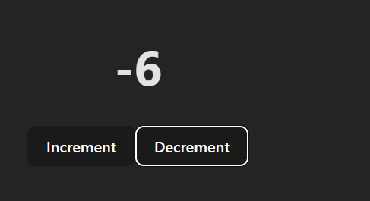

Approach 2: Functional Component
import { useState } from "react";
function App2() {
const [count, setCount] = useState(0);

const increment = () => {
setCount(count + 1);
};

const decrement = () => {
setCount(count - 1);
};
return (
<div>
<h1>{count}</h1>
<button onClick={increment}>Increment</button>
<button onClick={decrement}>Decrement</button>
</div>
);
}
export default App2;

- In the commercial furniture web-application add a like button under each product in the products page using react states.
import Furniture from './Furniture';

function App3() {
return (
<div className="grid-container App-header App">
<Furniture itemName="Linanas" itemPrice="29990" itemImg="https://www.ikea.com/in/en/images/products/linanaes-3-seat-sofa-with-chaise-longue-vissle-dark-grey__1013909_pe829463_s5.jpg?f=xxs" />

<Furniture />

<Furniture itemName="Nodeland" itemPrice="15990" itemImg="https://www.ikea.com/in/en/images/products/nodeland-wardrobe-with-3-doors-medium-brown__0836934_pe778612_s5.jpg?f=xxs" />

<Furniture itemName="Nolmyra" itemPrice="3990" itemImg="https://www.ikea.com/in/en/images/products/renberget-swivel-chair-bomstad-black__1025981_pe834276_s5.jpg?f=xxs" />

<Furniture />

<Furniture itemName="Knarrevik" itemPrice="899" itemImg="https://www.ikea.com/in/en/images/products/knarrevik-bedside-table-black__0858302_pe669481_s5.jpg?f=xxs" />

<Furniture itemName="Tufjord" itemPrice="42990" itemImg="https://www.ikea.com/in/en/images/products/knarrevik-bedside-table-black__0858302_pe669481_s5.jpg?f=xxs" />

</div>
);
}
export default App3;

Output
